Problem: Strange Counter

Bob has a *strange counter*. At the first second, , it displays the number . At each subsequent second, the number displayed by the counter decrements by .

The counter counts down in cycles. In the second after the counter counts down to , the number becomes  the initial number for that countdown cycle and then continues counting down from the new initial number in a new cycle. The diagram below shows the counter values for each time  in the first three cycles:

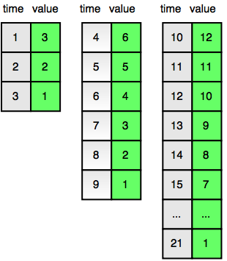

Given a time, , find and print the value displayed by the counter at time .

**Input Format**

A single integer denoting the value of .

**Constraints**

**Subtask**

* for  of the maximum score.

**Output Format**

Print the value displayed by the strange counter at the given time .

**Sample Input**

4

**Sample Output**

6

**Explanation**

Time  marks the beginning of the second cycle in which the counter displays a number that is double the initial number displayed at the beginning of the previous cycle (i.e., ). This is also shown in the diagram in the *Problem Statement* above.

Solution

int main()

{

long query, value, i=1;

cin>>query;

while(1)

{ //value is the pattern b/w the last time

of each cycle

value=(pow(2,i)*3)-3;

if( query > value)

{i++;}

else{break;}

}

cout<<value-query+1<<endl;

return 0;

}

`’Anshul AgGarwal